Project Design Phase-II
Technology Stack (Architecture & Stack)

Date | 5 April 2026
Team ID | SWTID-2026-8642
Project Name | Streamlining Ticket Assignment for Efficient Support Operations.
Maximum Marks | 4 Marks

Technical Architecture:
The technical architecture for the project “Streamlining Ticket Assignment for Efficient Support Operations” is designed to ensure efficiency, scalability, and reliability in handling support requests. The system follows a layered architecture consisting of a user interface layer, application layer, and data layer. The user interface allows customers and support agents to create, view, and manage tickets through web or mobile applications. The application layer processes ticket data, applies business rules, and automatically assigns tickets to appropriate agents based on predefined criteria such as priority, category, and workload. The backend is supported by a centralized database that stores user details, ticket information, and activity logs. Integration with notification services enables real-time alerts via email or SMS, ensuring timely responses. This architecture ensures smooth communication, faster resolution times, and improved overall support efficiency.
The guidelines for the project Streamlining Ticket Assignment for Efficient Support Operations ensure smooth and efficient functioning of the system. Users should register with valid details and securely log in to access the system. While creating tickets, users must provide clear descriptions, select appropriate categories, and set priority levels. Tickets should be assigned automatically based on workload or manually by the admin to ensure fair distribution. Users must be able to track ticket status, and support agents should update progress regularly until resolution. The system must follow strong security practices, maintain fast performance, and ensure 24/7 availability. Regular maintenance and monitoring are required to keep the system reliable and efficient.
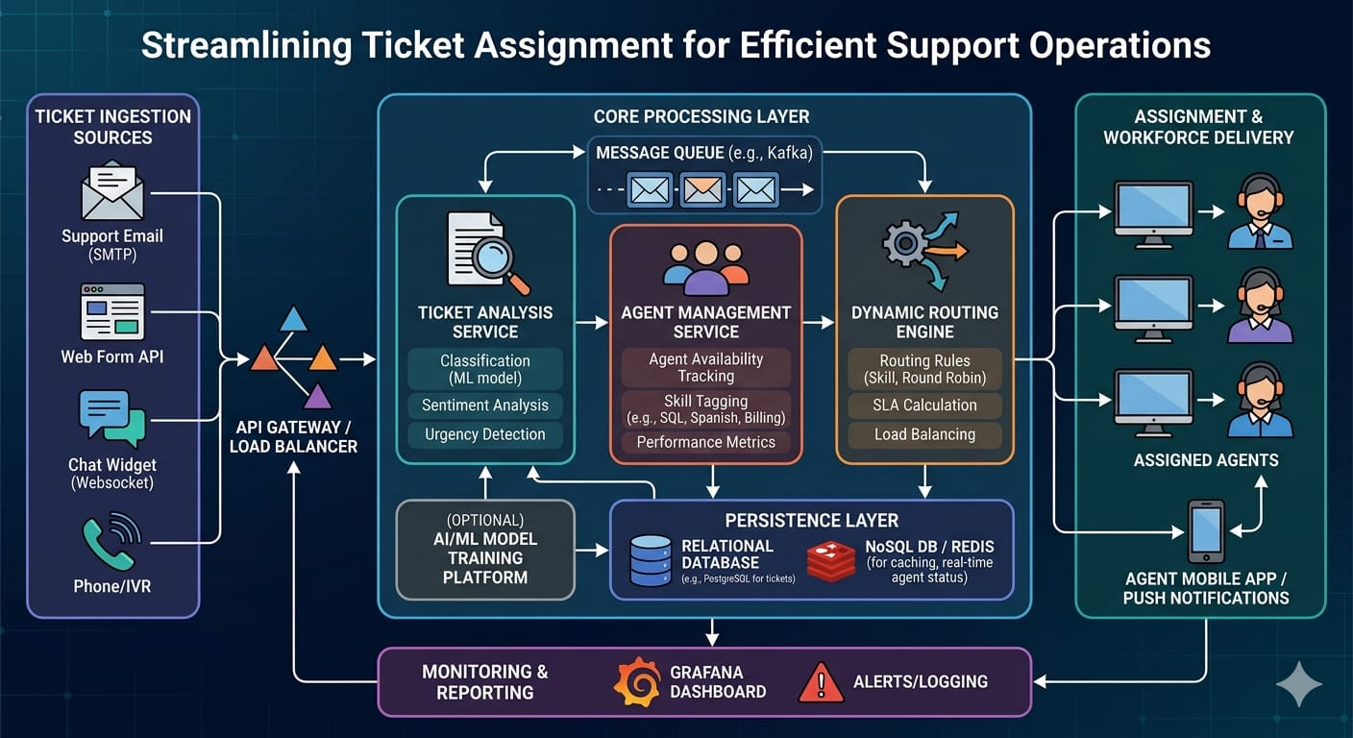

Table-1 : Components & Technologies:
S.No | Component | Description | Technology
 | User Interface | Interface for users (customers, agents, admin) to interact with the system (Web App / Dashboard) | HTML, CSS, JavaScript / Angular Js / React Js etc.
 | Application Logic-1 | Handles user registration, login, and authentication processes | Java / Python
 | Application Logic-2 | Ticket creation, categorization, and priority assignment logic | Python / Node.js
 | Application Logic-3 | Automated ticket assignment using rules or AI-based decision making | Machine Learning / Rule-based Engine
 | Database | Stores user data, ticket details, status, and logs | MySQL, NoSQL, etc.
 | Cloud Database | Cloud-based storage for scalability and remote access | Firebase / AWS RDS / MongoDB Atlas
 | File Storage | Stores attachments such as screenshots, documents in tickets | AWS S3 / Local Storage
 | External API-1 | Email and notification service for alerts and updates | SMTP / SendGrid API.
 | External API-2 | Integration for authentication or third-party login (Gmail, LinkedIn) | Google API / LinkedIn API
 | Machine Learning Model | Predicts ticket priority and assigns to appropriate support agents | Classification Model (AI/ML)
 | Infrastructure (Server / Cloud) | Deployment and hosting of application | AWS / Azure / Google Cloud / Local Server

Table-2: Application Characteristics:
S.No | Characteristics | Description | Technology
 | Open-Source Frameworks | Frameworks used for building the web-based ticket management system | React JS (Frontend), Node.js / Django (Backend)
 | Security Implementations | Secure authentication, data protection, and access control for users and admin | JWT Authentication, SHA-256 Encryption, HTTPS, Role-Based Access Control (RBAC)
 | Scalable Architecture | System designed to handle increasing users and tickets efficiently using modular architecture | 3-Tier Architecture (UI, Logic, Database), Microservices (optional), Docker
 | Availability | Ensures system is always accessible with minimal downtime | Cloud Hosting (AWS/Azure), Load Balancer, Distributed Servers
 | Performance | Optimized for fast response and handling multiple requests simultaneously | Caching (Redis), CDN, Optimized Database Queries

